ADC Board 4 Channel Notes

Board Features

4 Chan - 130MSPS 16 bit ADCs LTC2208 - Data clocked into 64k Sample FIFOs

1 buffered clock input to CPLD
1 buffered trigger input to CPLD
2 unbuffered coax I/O from CPLD
3 digital I/O from CPLD
4 interrupts to uCdimm5282

Ethernet Port RJ45 connector
1 COM Port to 9 pin D connector
1 COM Port to header
I2C Port to header
QSPI 4 wire Serial port with 4 chip selects to header
12 bit General Purpose I/O to header
6 10bit mux analog in or 4 digital I/O and 2 digital Outs to header

Various Info

Can't use chip selects 0, 3, 4, 5 and 6. CS0 boot select? CS3 not brought out? CS4, 5, and 6 are address lines. Only CS 1 and 2 can be used.
If we run the CS1, A2 and A3 through the CPLD, we can use the CPLD to clock X words before the data we want.

IPSBAR default = 0x4000_0000

Slow analog in and Slow analog out will be done through the QSPI port

Timing

1k word at 119MHz = 8.6uS
1k word at 102MHz = 10.0uS

Read and move data takes time

Required number of samples for each system.
S-Band Accelerator = 850nS = 88 samples
X-accelerator = 100nS = 12 samples
RF Gun = 64 samples
T-cav = 100nS = 8 samples
Phase Cavity = 1.25uS = 128 samples
BPMs = ????

LTC2208 Board Notes

LTC2208 Functions
LVDS (Pin 61): Data Output Mode Select Pin. Connecting LVDS to 0V selects full rate CMOS mode. Connecting LVDS to 1/3VDD selects demultiplexed CMOS mode. Connecting LVDS to 2/3VDD selects Low Power LVDS mode. Connecting LVDS to VDD selects Standard LVDS mode. - GND
MODE (Pin 62): Output Format and Clock Duty Cycle Stabilizer Selection Pin. Connecting MODE to 0V selects offset binary output format and disables the clock duty cycle stabilizer. Connecting MODE to 1/3VDD selects offset binary output format and enables the clock duty cycle stabilizer. Connecting MODE to 2/3VDD selects 2’s complement output format and enables the clock duty cycle stabilizer. Connecting MODE to VDD selects 2’s complement output format and disables the clock duty cycle stabilizer. - VDD - Resistor Selectable
RAND (Pin 63): Digital Output Randomization Selection Pin. RAND low results in normal operation. RAND high selects D1-D15 to be EXCLUSIVE-ORed with D0 (the LSB). The output can be decoded by again applying an XOR operation between the LSB and all other bits. This mode of operation reduces the effects of digital output interference. - - CPLD selectable
PGA (Pin 64): Programmable Gain Amplifier Control Pin. Low selects a front-end gain of 1, input range of 2.25VP-P. High selects a front-end gain of 1.5, input range of 1.5VP-P. 3.5dB difference - CPLD selectable
SHDN (Pin 19): Power Shutdown Pin. SHDN = low results in normal operation. SHDN = high results in powered down analog circuitry and the digital outputs are placed in a high impedance state. 20mS recovery time - CPLD selectable
DITH (Pin 20): Internal Dither Enable Pin. DITH = low disables internal dither. DITH = high enables internal dither. Refer to Internal Dither section of this data sheet for details on dither operation. - CPLD selectable

FIFO

FIFO OW (output width = 9, /18) pin 73 GND
FIFO /BE (not Big-Endian) pin 69 GND
FIFO /LD (Load-/PAE and /PAF Flags) GND
FIFO FWFT/SI (/Standard Mode) GND
FIFO FSEL0 FSEL1 (Flag value select) GND
FIFO IP (Interspersed Parity) GND
FIFO PFM (Prog Flag Mode) GND
FIFO RM (Retransmit Mode) GND
FIFO /RT (Retransmit) VCC
FIFO /SEN (Serial Enable) VCC
FIFO /WEN (Write Enable) - CPLD Timing critical
/WEN to /WCLK Tens=2.5nS Tenh=0.5nS
CPLD will resync trigger to write clock
FIFO /REN (Read Enable) - CPLD separate 4 FIFOs

FIFO /PRS - (Partial Reset) - CPLD
FIFO /MRS - (Master Reset) - CPLD
The FIFO needs time after reset pulse before writing.
/PRS should be used instead of /MRS
15nS Prior to /MRS or /PRS: /REN, /WEN, /RT, and /SEN must be high and stay high until after recovery.
Reset PW = 10nS and recovery is 10nS
FIFO /OE and RCLK for each FIFO are connected to the CPLD

/FF (FiFO Full) - Connect to TP
/FE (FIFO Empty) - Connect to TP

PARTS

Serial
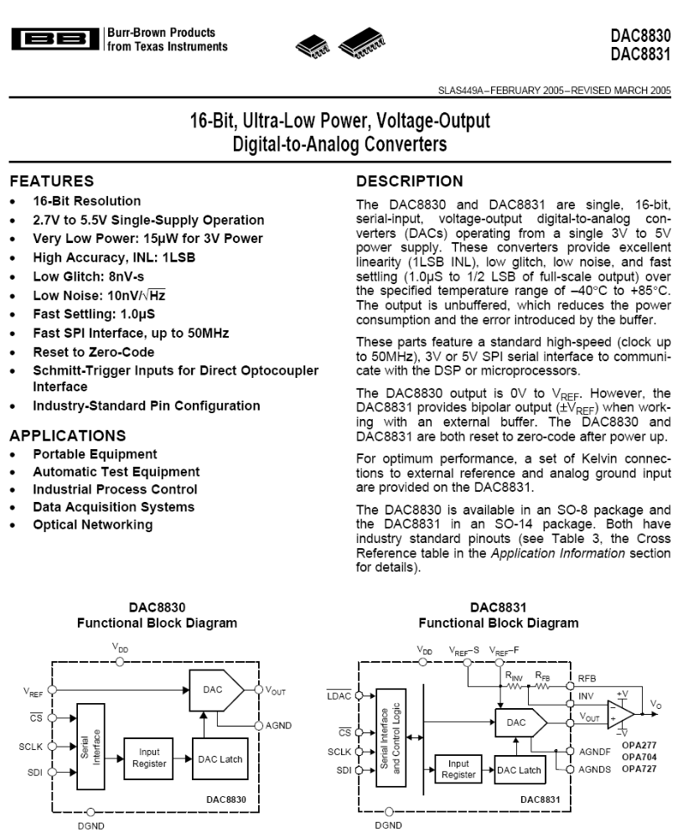
TI DAC8831

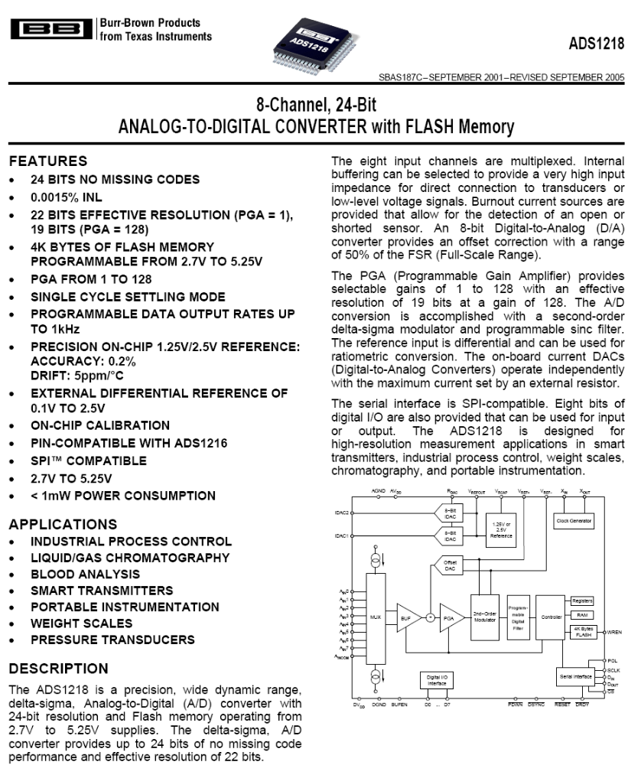
TI ADS1218

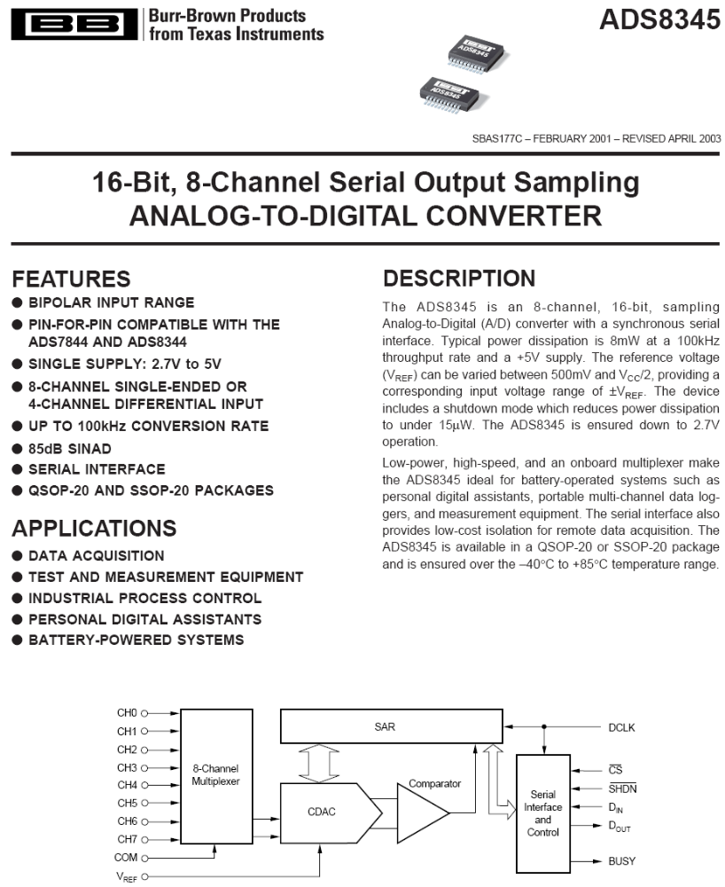

TI ADS8345
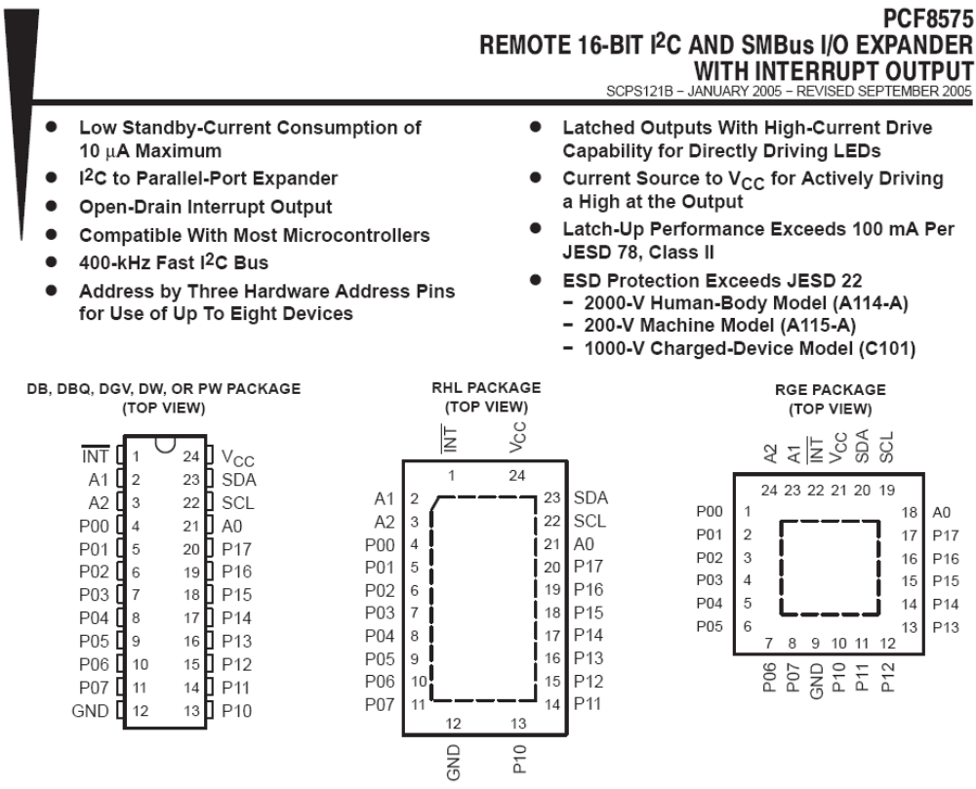
TI PCF8575
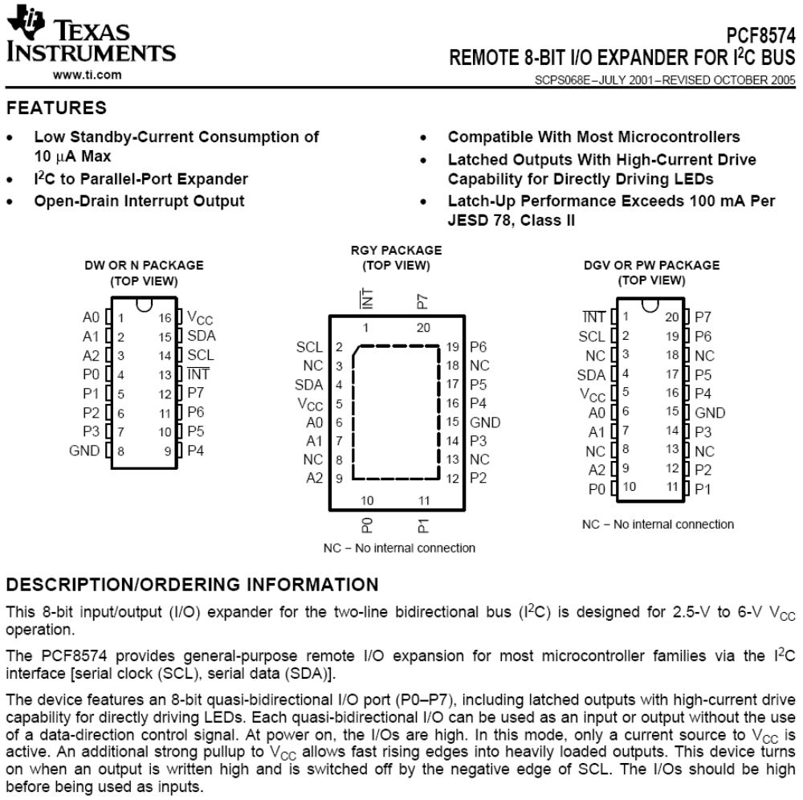
TI PCF8574

